Land + Water + Seeds = Food
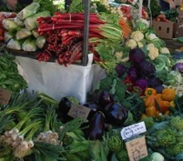
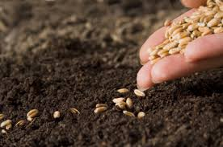
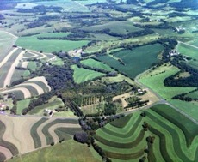
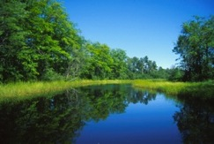

Conference on Friday & Saturday, March 14- 15, 2014
UW-Baraboo Campus, 1006 Connie Rd, Baraboo, WI
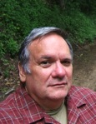
Friday: 6:30 – 9:00 p.m.
Featuring David Rhodes
Author of Driftless and Jewelweed: The Novel
Followed by Movie Night: Several short films will be shown

Saturday Conference: 8:00 a.m. to 5:30 p.m.

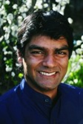
Followed by John Kinsman Beginning Farmer Food Sovereignty Prize Reception & Dinner and Ceremony
5:30 – 9:30 p.m.
Featuring Raj Patel
Author of The Value of Nothing and Stuffed and Starved
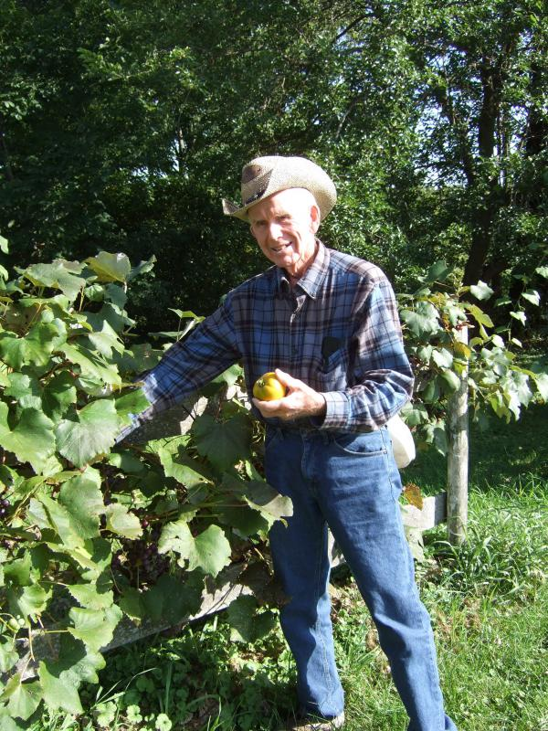

Join us to Honor the memory and legacy of John Kinsman, founder of the Family Farm Defenders

Saturday, March 15, 2014 -- 8:00 a.m. to 5:30 p.m.
UW – Baraboo/ Sauk County

Tentative Schedule
8:00 a.m. Registration and Breakfast – Lange Center
9:00 a.m. Welcome -- John Peck and Joel Greeno – Umfoefer Building—Room A-4
9:15 a.m. Panel – This Land is My Land, This Land is Your Land…and Land Grabbing
Moderator: Ruth Simpson Panelists: Curt Meine, Ben Burkett, Ken Schmitt
10:30 a.m. Break
10:45 a.m. Workshops 1
Noon Lunch – Lange Center
1:00 p.m. Panel – Is the well dry? Water Resources at Risk
Moderator: Arleen Kanno Panelists: Bob Clarke, Kimberlee Wright, Rep. Dana Wachs
2:15 p.m. Break
2:30 p.m. Workshops 2
3:45 p.m. Break
4:00 p.m. Panel – Food Justice: Carrying the Message to Media and the Masses
Moderator: Rebekah Wilce: Panelists: Raj Patel, Patty Lovera, Ron Seely
5:15 Wrap-up

Workshops 1: 10:45 to Noon
A. Local control and State Preemption – Who’s in Charge?– Room A-4 – Strategy Session – Edie Ehlert,
B. Fair Trade and Trade Agreements – Room A-30
Jim Goodman, Mary Bottari, John Peck
C. Seeds of Change: The case against GMOs and for Labeling – Room A-18 – Patty Lovera, Mark Kastel

Workshops 2: 2:30 – 3:45 p.m.
D. Fighting CAFOs -- Strategies for Winning
Strategy Session – Room A-4 – Nancy and Lynn Utesch, Bill Iwen,
E. Land O’Lakes Campaign – Fair Prices for Dairy Farmers – Room A-30 – Strategy Session – Bob Wills, Joel Greeno
F. The Good Local Food Movement – Room A-18
Rebecca Goodman, Inga Witscher, Jasia Steinmitz, Oscar Ferreira
###
Other speakers will be added to the schedule when confirmed.
All the panels and workshops will be held in the lower level of the Umhoefer Building. All meals will be held in the cafeteria in the John and Murrel Lange Center.

Full Registration – March 14 & 15
Before 3/1 After 3/1
FFD Member ☐ $100 ☐ $115
Non-FFD Member ☐ $120 ☐ $135
Student * ☐ $50 ☐ $ 65
* No charge for UW-Baraboo Students
3/14 Evening: ☐ $10 ☐ $10
Students No Charge

Saturday Conference Only:
FFD Member ☐ $50 ☐ $65
Non-FFD Member ☐ $70 ☐ $85
Student ☐ $20 ☐ $35
3/15 Dinner and Ceremony ☐ $50
Students……. ☐ $30
Total Enclosed…………_______________
Make check payable to Family Farm Defenders
Scholarships may be available, check with FFD office at 608-260-0900 or familyfarmdefenders@yahoo.com.
Registration Form
Name: ______________________________________________________________
Organization:_______________________________________________________
Address: ____________________________________________________________
City: ______________________________ State: _________ Zip: ____________
Email: _______________________________________________________________

Meals: ☐ Vegetarian option
Please sign up by March 1 to be assured a meal. There is a surcharge of $15 for registering after March 1 for the conference.

Preferences for Workshops:
Morning: ☐ A ☐ B ☐ C
Afternoon: ☐ D ☐ E ☐ F

FFD reserved a block of rooms at the Clarion Hotel, 626 W. Pine St. (Hwy 12) in Baraboo. It is near the UW-Baraboo campus. Please call (608) 356-6422 to reserve a room by Feb 15th

